**PROJECT REPORT**

**Analyzing the Performance Efficiency of The Radisson Hotels using Data-Visualization Techniques**

**Team ID : NM2023TMID00783**

**Team Size : 5**

**Team Leader : KALIDHASAN R**

**Team member : ASHOK KUMAR K**

**Team member : ARUN KUMAR D**

**Team member : VALLARASU K**

**Team member : RAMKUMAR G**

**INTRODUCTION:**

**• Overview:**

**Radisson hotel is an international chain of upscale Hotel. It has roots dating back to the opening of the Royal Hotel in Denmark in 1960.**

**Radisson hotel is the world’s first designer hotel. It is known for its creative hospitality and innovative spirit.**

**• Purpose:**

**At Radisson Hotel they strive to be the first choice in the mind of guest, owners and talent.**

**The Radisson Hotels are more comfortable and relaxing.**

**They mainly concentrate on satisfaction of each individual guests.**

**PROBLEM DEFINITION AND DESIGN THINKING:**

**• Empathy:**

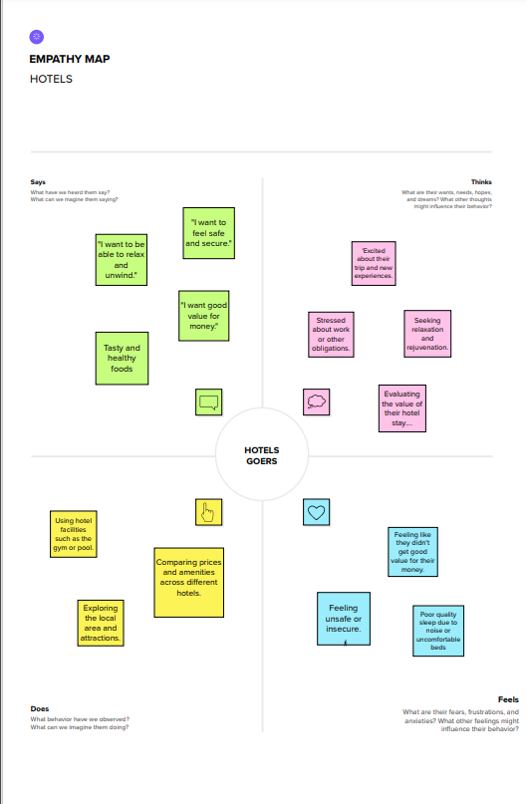

**IDEATION AND BRAINSTROMING MAP:**

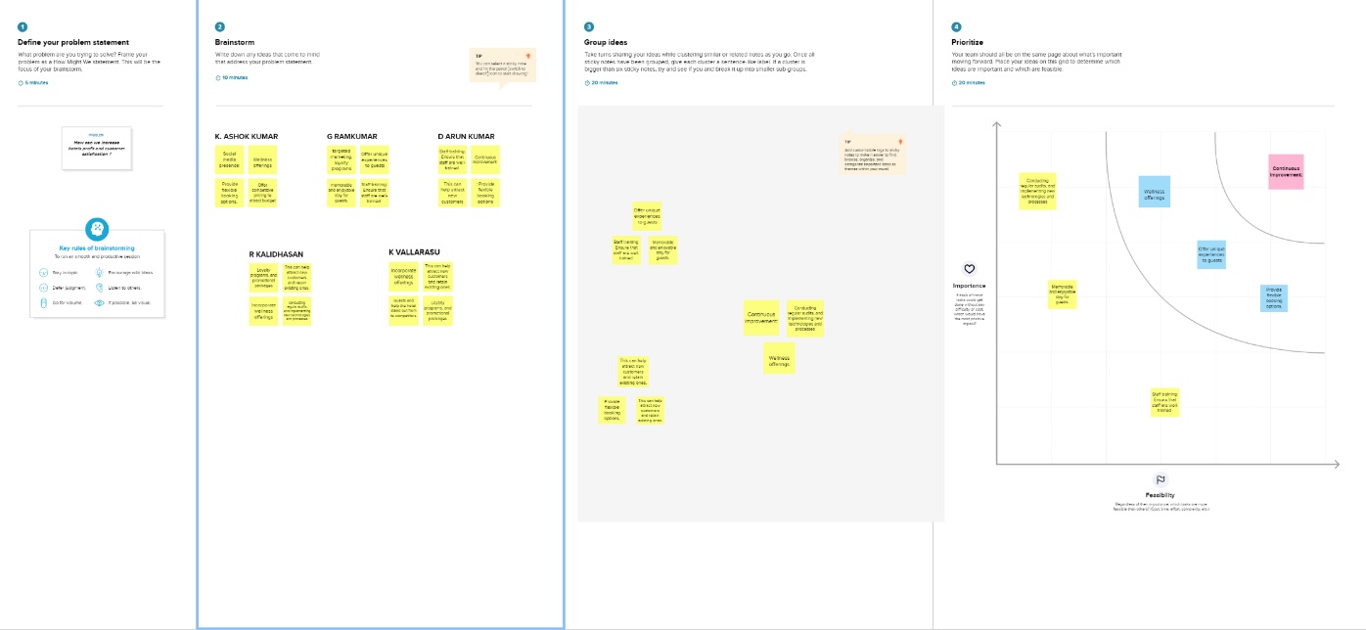

**RESULT:**

**Dashboard**

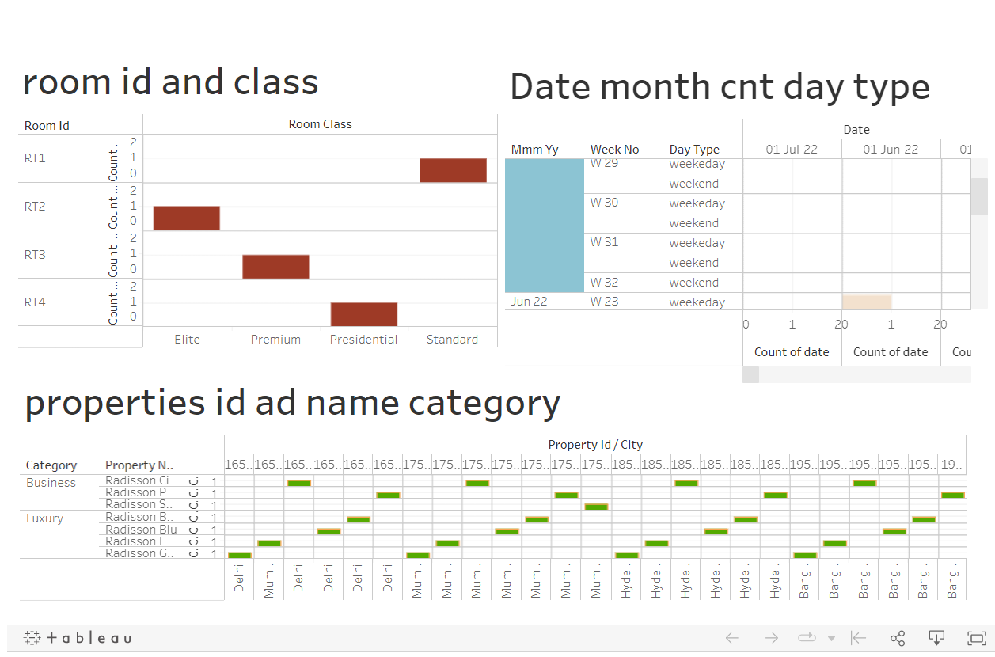

**Story**

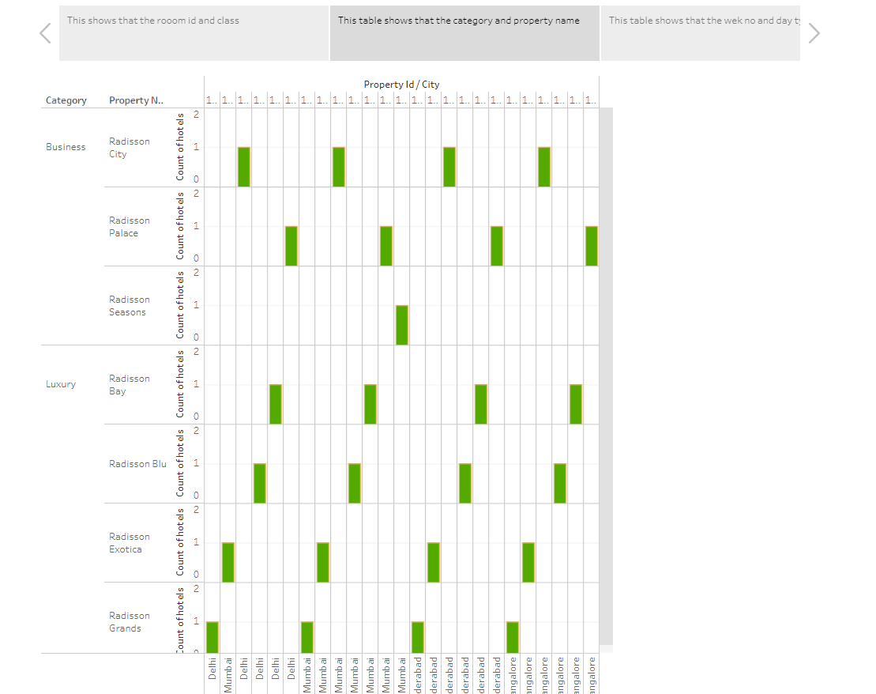

**Web Integration**

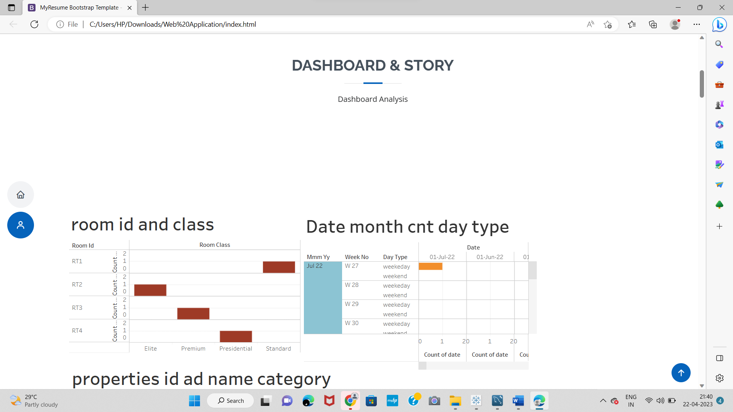

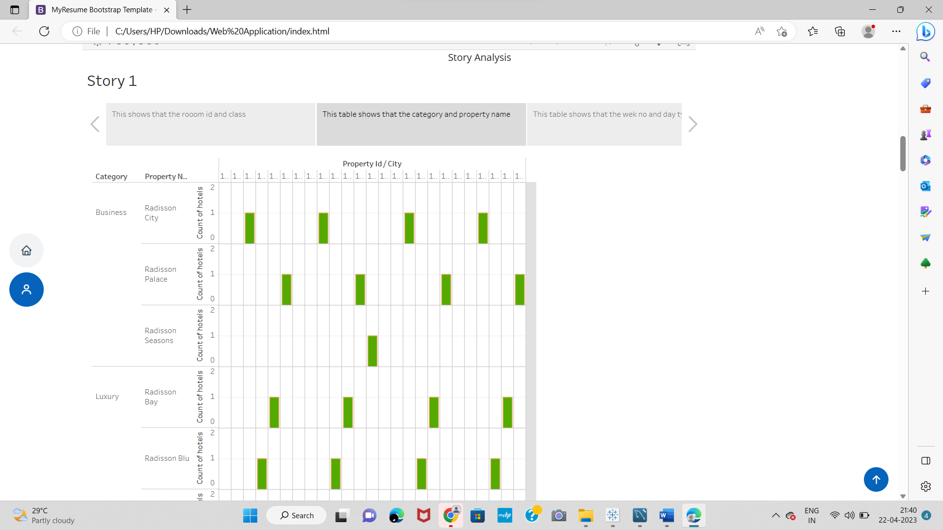

**ADVANTAGES AND DISADVANTAGES:**

**• Advantages:**

**Visualized Data is processed faster.**

**Data Visualization dashboards support visual learners.**

**Examine previous booking patterns to help increase future company rates.**

**Compare pricing with competitors to develop an effective pricing strategy.**

**Analyse guest spending behaviour to identify your most profitable segments.**

**• Disadvantage:**

**Roots on the street side are quite Noisy, there are aften long queues waiting to check-in order.**

**Radisson Hotels are overpriced.**

**There is lack of in-room technology.**

**Not economically friend for poor and middleclass family.**

**There are poor online reviews so that guests may have negative feedback.**

**APPLICATIONS:**

**To provide the best service and a flawless experience to customers from start to finish.**

**Provide best quality of service to increase guest satisfaction.**

**Best quality of food.**

**Reasonable price.**

**CONCLUSION:**

**Our growth strategies and unique business model make us one of the most attractive and respected partners in the industry.**

**FUTURE SCOPE:**

**Radisson plants to add too Hotels into by 2025: CEO Pedri Gonzalez**

**The authentication has been provided by the science tangents initialize (SBTI) a partnership Between experts such as CDP and united business.**